MESMER
Master Equation Solver for Multi-Energy well Reactions
User’s Manual

Struan H. Robertson, David R. Glowacki, Chi-Hsiu Liang, Chris M. Morley, and Michael J. Pilling

Acknowledgements
Stuff here…

Contents
Acknowledgements 2
Contents 3
1. Introduction 5
1.1. The Unimolecular System and the Master Equation 5
1.2. Program Features 6
1.3. Data Structures 6
2. Getting Started 7
2.1. Compilation and Execution 7
2.1.1. Windows 7
2.1.2. UNIX 7
2.1.3. QA test suite 8
2.2. Input File Structure 8
2.2.1. moleculeList 9
2.2.2. reactionList 13
2.2.3. me:conditions 16
2.2.4. me:modelParameters 18
2.2.5. me:control 19
2.2.6. Examples 21
3. Test Suite 25
3.1. N-Pentyl Isomerization 26
3.2. Cyclopropene Isomerization 27
3.3. H + SO₂ 28
3.4. OH + C₂H₂ 29
3.5. O₂ + CH₃CO 30
4. Adding Functionality 31
4.1. Modifying the Input File 31
4.2. Plug-in Classes 31
4.2.1. Density of States Calculations 31
4.2.2. Microcanonical Rates Calculations 31
4.2.3. Tunneling Corrections 31
4.2.4. Collisional Energy Transfer Models 31
5. MESMER files explained 32
5.1. Output files of calculation 32
5.1.1. mesmer.test 32
5.1.2. mesmer.log 35
5.1.3. XML output 35
5.2. Other files 35
5.2.1. source.dot and source.ps 35
5.2.2. mesmer1.xsl, mesmerDiag.xsl and switchcontent.xsl 35
6. Theoretical Basis 37
References 45
Appendices 47
Mesmer FAQ 49

Introduction

The Unimolecular System and the Master Equation
The modelling of unimolecular systems has application in industrial and environmental contexts. The quantities of particular interest are the rate coefficients, time dependent species profiles, product yields, and branching ratios of the system being investigated. Each of these quantities typically have a complex dependency on pressure and temperature. The modelling of industrial or environmental process often involves conditions that are difficult to access experimentally and so it is important to be able to generate experimentally validated rate coefficient models that can be used in large scale simulations. In recent years a great deal of progress has been made in the understanding and modelling of unimolecular systems at a range of temperatures and pressures. A common feature in much of the work in this area is the use of stochastic techniques for describing the evolution of unimolecular systems and in particular the master equation (ME). MESMER is capable of solving the energy grained master equation (EGME) for a unimolecular system composed of an arbitrary number of wells, transition states, sinks, and reactants.
A unimolecular system is characterised by one or more potential wells (local minima) on the potential energy surface (PES) which describes the energy of the atoms as a function of position. Each well represents a (meta-) stable species that can in principle be isolated. Wells are connected by transitions states (TS) and a species in one well may be converted to another by passing through the TS that connects the wells. In many systems the TS can be associated with a saddle point on the system PES and so there is an energy barrier to interconversion of species. Thus, to convert from one species to another, the reactant must be activated – i.e., energy must be supplied to overcome the barrier separating the two wells. Typically, energy is supplied through inelastic collisions with bath gas molecules - the reactant will undergo a number of collisions with bath gas molecules some of which will be activating (net increase in reactant energy) some will be deactivating (net decrease in reactant energy). Since collision events and the amount of energy transferred are random quantities, the energy transfer process can be regarded as a random walk, and treated using techniques from stochastic process theory.

Program Features
Previous developments of master equation Fortran codes are inferior due to their inflexibility in extending to more complex systems. The main goal of MESMER is to incoporate various functionalities providing ease of use in the application of master equation to gas kinetics. MESMER has the following features:
1. Use standard XML data representation as input stream, in which comments are easily inserted/removed to assist human readability.
2. Open source C++ codes, that can be compiled on most plateforms.
3. References are given in proper positions where the methodologies are used.

Data Structures

Getting Started

Compilation and Execution

Windows
For WIN32 systems, if a excutable release is not available or if you want to build it by yourself for some purposes, the solution file of VS2008 is located in \Windows VC8 folder. Open the file MESMER.sln under Windows Visual Studio to open the solution. Click the bottom Build the Solution will have the executable built in \Windows VC8\Mesmer.
MESMER executable can be called with flags, to find out what flags MESMER accepts to alter the output, one can call MESMER by the syntax below:
mesmer.exe -?
MESMER will than output a list of usage.

UNIX
To compile Mesmer in Linux systems one needs to first compile QD and TinyXML package in the trunk folder. For QD, the installation steps are described in INSTALL file of the /qd folder. For TinyXML package the library has to be created by the following command line order under the /tinyxml folder:

make –f MakeLib
To compile MESMER object files, one needs to change the header file MesmerPrecision.h so that it refer to the correct filenames (usually are qd_real.h and dd_real.h ). MESMER can be built with different versions of QD. For the compilation of QD package please refer to http://crd.lbl.gov/~dhbailey/mpdist/ . Linking MESMER with QD one needs to refer to the location of libqd.a. Also, change Makefile in /src in the fields LIBS and INCS if necessary. To do this, after a successful installation of QD and Tinyxml packages, paste the path of libqd.a and tinyxml.a into the Makefile of MESMER as the following
LIBS := ../tinyxml/tinyxml.a /usr/local/newqd/lib/libqd.a
And in INCS, give the absolute or relative location of qd_real.h and dd_real.h folder like this
INCS := -I../tinyxml/ -I/usr/local/qd/include
where /usr/local/qd/include is the location of the include folder. After installing both packages, go back to /src folder and do
make
or
make install
This command will copy the executable and to /bin folder after a successful compilation. If you need to recompile MESMER, you can also use the command
make remake
This will remove the previous built object files in /src folder and do a clean recompile/installation. The way to call MESMER in UNIX/Linux systems is similar to that in Windows systems. The only difference is on the naming of the executable. One can call MESMER in UNIX/Linux systems by the syntax as the following,
./mesmer.out filename.xml

QA test suite
Test input data are provided in the MesmerQA folder, which is listed in Page 25. At the first time one install MESMER, he should check the precision and performance by the supplied QA batched functionality.

Input File Structure
The MESMER input file is in XML format (e.g., inputfile_name.xml). For those with no knowledge of XML syntax, both the construction and viewing of an input file is easily facilitated with the use of an XML editor. The XML format of the MESMER output file allows for its viewing in applications such as Firefox or Internet Explorer so long as the *.xsl files, mesmerDiag.xsl and mesmer1.xsl, are included in the same directory as the inputfile_name.xml file. Several XML editors are available: for example, free editors include the Microsoft XML Notepad, or that included with Microsoft’s Visual Studio Express Program. In the following discussion of MESMER input, the XML tree structures shown for different parts of the MESMER input were generated using Microsoft XML Notepad to view the input file for Acetyl_O2_isomerization.xml, which is included in the test suite; however, with a very basic knowledge of XML syntax, any editor may be used to construct a MESMER input file. The description of MESMER input that follows concentrates more on the structure of the MESMER input file rather than elementary XML syntax. In addition to the discussion that follows, anyone attempting to construct a MESMER input file should inspect the input files included in the test suite. Inspection of these files should enable understanding of the very basic XML syntax required for constructing MESMER input.
The MESMER input file is composed of the following sections, all of which have straightforward titles, and are detailed further in what follows:
- moleculeList, which specifies the molecules or atoms relevant to the ME system, as well as associated properties of the molecules;
- reactionList, which specifies the reactions relevant to the ME system to be modelled, and associated properties of the reactions;
- me:conditions, which specifies the conditions (e.g., temperature, pressure, bath gas) under which a particular ME model is to be run;
- me:modelparameters, which specifies the parameters relevant to the model (e.g., grain size and the maximum grain energy);
- me:control, which specifies program options concerning the content of the output file;

moleculeList
moleculeList is composed of each molecule involved in the ME system, and represents the distinct molecules or molecular configuration involved in the ME system. A molecule may be one of the following: (1) an individual reactant in an association process, (2) an association product (i.e, an adduct), (3) an isomer, (4) a transition state, (5) an individual product from a dissociation reaction, or (6) a bath gas.
Each molecule includes the following, and the moleculeList tree structure is given in Fig 2.1 :
- an id attribute, which is used to identify the molecule in other portions of the input file (e.g., the reactionList) , and an id of a molecule can be arbitrary as long as it is composed of ASCII characters but must be distinct from that of other molecules;
- a description attribute, which is available for the user to add their own comments regarding a particular molecule should they so choose;
- an atomarray, whose elements are each individual atom within the molecule. In the case that a molecule is no more than a single atom, as is often true for a reactant in an association reaction, a product in a dissociation reaction, or a bath gas, then atomarray has only a single constituent atom. Similar to molecule, each atom has the following attributes: an id, which is used to identify the atom in other portions of the input (e.g., the bondarray), and an elementType;
- A bondarray, whose elements are each bond between the constituent atoms in a molecule. Each bond has the following attributes: atomRefs2, which specifies atoms that are bonded (using the id attribute of atom) and order, which specifies the bond order. In the case that a molecule is no more than a single atom, it does not have a bondarray;
- A propertyList array, which includes the following:
  - me:DOSCMethod, which specifies the method for MESMER to use in calculating rotational density of states. Presently, classical calculations of the rotational density of states are available, and are specified with the text Classical rotors. Table 2.1 gives the classical methods that are presently included in MESMER, and the manner in which the program recognizes the type of calculation to perform. Bath gas molecules and products of sink reactions do not require calculation of the rotational state density and thus do not require a specification of me:DOSCMethod; however, specifying such a method will not affect program execution.

Type of rotor | MESMER recognition criteria | DOS expression
not a rotor | no nonzero rotational constants available in the input | 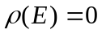
2d linear classical rotor | only one or two nonzero rotational constants provided in the input | 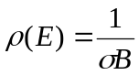
3d classical rotor | three rotational constants provided in the input | 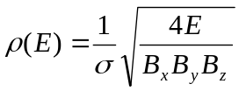
Table 2.1: methods for calculating DOS that are presently available in MESMER

  - property elements of a molecule. Each property element has a dictRef attribute which specifies what type of property is subsequently defined. A property type which requires a list, such as vibrational frequencies and rotational constants, is specified in an array, whereas one which requires only a single number, such as zero point energy location or a symmetry number, is specified to be scalar. For property types which have associated units, (e.g., vibrational frequencies, rotational constants, and zero point energy) the units are specified as an attribute of array or scalar. Unitless quantities such as spin multiplicity, symmetry number, or frequency scale factor, are specified to be scalar. Table 2.2 gives the values of dictRef (i.e, property attributes) currently recognized by MESMER, specifies whether they are scalar or array, and specifies the units presently available in MESMER. There are two important points to remember for specifying zero point energy:
    - While units are available for input of a molecule’s ZPE, the selected units must be consistent for every molecule in the input file with respect to some arbitrary reference energy.
    - For association and dissociation reactions, the respective sum of the reactant and product ZPEs for each molecule must equal the total energy of the products or reactants. That is, if the ZPE of A+B is equal to x kJ/mol for a particular system, there are infinite number of ways in which this may be specified so long as the ZPE of A added to the ZPE of B is equal to x kJ/mol.

dictRef value | Scalar or array | Available input units
me:ZPE | Scalar | kJ/mol or kJ per mol  cm-1 or wavenumber  kcal/mol or kcal per mol  Hartree or au
me:rotConsts | Array | cm-1
me:symmetryNumber | Scalar | unitless, no units specification
me:frequenciesScaleFactor | Scalar | unitless, no units specification
me:vibFreqs | Array | cm-1
me:MW | Scalar | Amu
me:spinMultiplicity | Scalar | unitless, no units specification
me:epsilon | Scalar | K, no units specification
me:sigma | Scalar | Angstroms, no units specification
me:deltaEDown | Scalar | cm-1
Table 2.2: values of dictRef recognized by MESMER, whether the associated input is scalar or an array, and the available units for the input values.

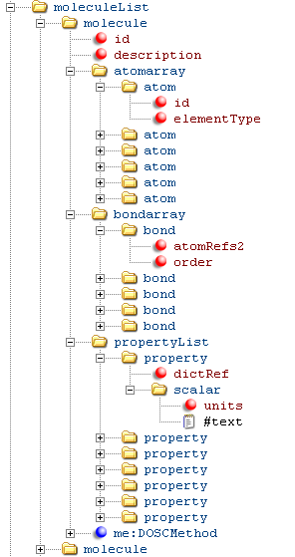
Figure 2.1: tree structure for moleculeList

Molecular variables and its relation in the input file
The following table is essential variables for molecules that are in the MESMER calculation. The variables in grey boxes are not input by user, but calculated by MESMER according to the input parameters.
parameter | Bath | TS | ExcS | DefS | Sink | MM
Mass | • | • | • | • | • | • | B
σ | • |  |  |  |  |  | B
ε | • |  |  |  |  |  | B
I_{xyz} |  | • | • | • | • | • | C
D_{sym} |  | • | • | • | • | • | C
H_{f} |  | • | • | • | • | • | C
υ_{f} |  | • | • | • | • | • | C
spin |  | • | • | • | • | • | C
E_{exc} |  | • | • | • | • | • | C
N_{cell} |  | •RRKM | • | • | • | • | C
N_{grn} |  |  | • | • | • | • | G
E_{grn} |  |  | • | • | • | • | G
P_{init} |  |  |  | • | • | • | P
f_{eq} |  |  |  | • | • | • | P
<ΔE>_{d} |  |  |  |  |  | • | X
f_{colli} |  |  |  |  |  | • | X
_{size} |  |  |  |  |  | • | X
dist |  |  |  |  |  | • | X

reactionList
reactionList is composed of each individual reaction that may occur in a ME system, and the reactionList tree structure is given in Figure 2.2. Effectively, the reactionList specifies which molecules are connected via which transition state. A reaction may be one of the following: (1) an isomerization, (2) an association, or (3) a dissociation.
Each reaction may include the following:
- An id attribute, which is used to identify the reaction;
- One or more of a reactant and one or more of a product. An isomerization reaction has one reactant and one product, an association reaction has two reactants and one product, and a dissociation reaction has one reactant and two products. reactions may or may not have a me:transitionState, which is discussed further below. All reactants, products, and me:transitionStates are molecules, and have:
  - A ref, which should be identical to the molecule id specified in moleculeList, and
  - A me:type, which specifies the molecule’s role in the ME model of the system. The possible values of me:type are given in Table 2.3.
- If me:type is excessReactant, then reaction requires a value of the excess reactant number density associated with me:excessReactantConc (in units of molecules cm⁻³);
- A me:tunnelling specification, which indicates whether and what sort of tunnelling corrections are to be implemented for a particular reaction. Presently, the only tunnelling correction that has been implemented is one dimensional tunnelling through an asymmetric eckart barrier, using the method described by Miller,¹ and specified in MESMER with Eckart;
- A me:MCRCMethod specification, which indicates how microcanonical flux through the transition state is to be treated for a particular reaction. Presently, there are two methods for treating the transition state: (1) If me:transitionState is specified, then the Simple RRKM method, which uses the well known RRKM expression to calculate k(E)s, may be used. (2) If no transition state is specified, then Mesmer ILT may be used. This specifies that k(E)s are calculated using an inverse Laplace transform on k∞(T)s, which may be experimentally measured or theoretically calculated. This method is often convenient for reactions that do not have a well defined energy barrier;
If Mesmer ILT is specified, then reaction requires three parameters from an Arrhenius fit to the k∞(T)s. The expression used by MESMER is k∞(T) = A∞ × (T^{n}) × exp(-E/RT), where A∞ is the preexponential factor (me:preExponential), E is the activation energy (me:activationEnergy), and n accounts for curvature in the observed k∞(T)s (me:nInfinity).

me:type value | MESMER definition
deficientReactant | Deficient reactant in an association or exchange reaction; modelled using a pseudo first order bimolecular source term and assumed to be thermalized in the ME model. Presently, reversible association reactions and irreversible exchange reactions are available
excessReactant | Excess reactant in an association reaction; its large concentration relative to the deficient reactant allows a pseudo first order treatment of the association step
modelled | Molecule that may undergo relaxation via collisions with the bath gas
transitionState | Molecular configuration that represents the phase space flux bottleneck for a particular reaction
sink | product molecule that acts as an infinite sink (i.e., an irreversible loss) from a particular well modelled in the ME
Table 2.3: different values of me:type and their corresponding definitions in MESMER

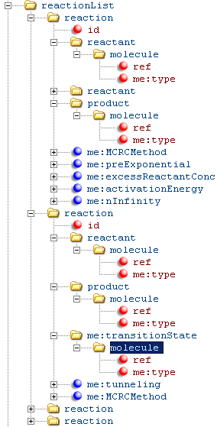
Figure 2.3: tree structure for reactionList; one of the reactions shown features a transition state and uses simple RRKM as well as tunnelling corrections for calculating microcanonical flux; while the other uses the MESMER ILT method for calculating microcanonical flux.

me:conditions
The tree structure for me:conditions is shown in Fig 2.3, and it includes the following elements:
- A specification of the me:bathGas, which is identical to the id attribute associated with the bath gas molecule in the moleculeList. The syntax should look like:
<me:bathGas>He</me:bathGas>
- me:PTs, which is used to specify the pressure (me:P) and temperature (me:T) at which the ME model is to be run. me:PTs includes the specific pressure and temperature pairs, me:PTpair at which at particular master equation model is to be run. The number of me:PTpairs tells MESMER how many ME simulations to run. For example, three me:PTpairs would result in ME runs at three specified temperature and pressure pairs. Each me:PTpair requires temperature and pressure specification. Temperature is input in Kelvin, but the pressure may be input in any of several units, which must be specified in me:units. The units recognized by MESMER for pressure input include: (1) number density, which may be specified as particles per cubic centimeter, number density, or PPCC; (2) torr, specified as Torr or mmHg; (3) millibar, specified as mbar, (4) atmospheres, specified as atm, and (5) pounds per square inch, specified as psi.
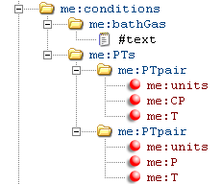
Figure 2.5: tree structure for me:conditions
- me:InitalPopulation, which specifies the initial population for each species in order to get the time evolution of the system. If there is a source term (i.e., an association reaction), MESMER will automatically set its initial population to 1.0. If there is more than one source term, MESMER will set the population of the first source term it encountered to 1.0, leaving the populations of the other source terms nil. If there is no source term in the system, MESMER will set the population of the first isomer it encountered to 1.0. Otherwise, user can specify the initial population of the species by using this element, the syntax should look like the following:
<me:InitalPopulation>
<molecule ref="cyclopropene" me:population="1.0" />
</me:InitalPopulation>

me:modelParameters
The tree structure for me:modelParameters is shown in Fig 2.3, and it includes the following elements:
- me:grainSize includes a specification of the grain size to be used in partitioning the system phase space. It has an associated value and associated units. The units available are are identical to those given in Table 2.2 for specification of ZPE. For a convergent solution of the ME utilizing the exponential down model, the grain size should be smaller than the 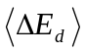 values of any of the modelled molecules.
- me:energyAboveTheTopHill specifies the energy range to be spanned by the grains, where the units are kT. The value of this parameter sets up a model wherein the energy grains span a region possessing x kT of energy in excess of the highest energy stationary point. In general, the maximum grain energy in the ME should be at least 20 kT above the highest energy molecular configuration, including reactants. If the maximum grain energy is too large, then numerical errors may result given that the probability for upward collisions is so small as to exceed machine precision.
- me:maxTemperature applies if more than one me:PTpair has been specified in me:conditions. If me:maxTemperature is not specified, then each ME run at a particular me:PTpair will use the me:energyAboveTheTopHill value to determine the maximum grain energy – i.e., the maximum grain energy will be different at different temperatures. Using me:maxTemperature makes the maximum grain energy at each me:PTpair identical, choosing the maximum grain energy to be x kT above the highest energy stationary point, where T is equal to the value set in me:maxTemperature regardless of the temperature specified in the me:PTpair.
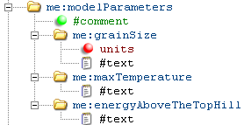
Figure 2.7: tree structure for me:modelParameters

me:control
The tree structure for me:control is shown in Fig 2.3. It includes several elements, all of which determine the content of the output file and may be turned off and on by commenting or uncommenting anyone of the following alphabetically listed items:
- me:calculateRateCoefficinetsOnly, which makes MESMER to calculate only rate coefficients without doing diagonalization.
- me:eigenvalues, which prints the eigenvalues obtained from diagonalization of the full system collision matrix. The text included within this element specifies how many eigenvalues to truncate in the printing. If ngrn is the number of grains in the collision operator, and the value in me:eigenvalues is x, then ngrn – x eigenvalues will be printed. x = 0 indicates that all of the eigenvalues should be printed.
- me: gridSearch, which does grid search for the user provided range and stepsizes for every parameter. χ² for every point of condition is then calculated against the experimental data user provided. Parameters for grid search include me:ZPE and me:deltaEDown for every molecular species, me:preExponential, me:activationEnergy, and me:nInfinity.
- me:printCellDOS, which prints out the cell DOS for the wells in the ME system
- me:printCellTransitionStateFlux, which prints out cell transition state fluxes.
- me:printCollisionOperatorColumnSums, which prints column sums of the full, normalized reaction (collision) operator.
- me:printGrainBoltzmann, which prints out the normalized equilibrium grain population all wells in the ME system.
- me:printGrainDOS, which prints out the grain DOS for the wells in the ME system
- me:printGrainkbE, which calculates k(E)s for backward reactions specified in the reactionList.
- me:printGrainkfE, which calculates k(E)s for forward reactions specified in the reactionList.
- me:printGrainedSpeciesProfile, which prints out time evolution of every grain in the logarithmic time scale.
- me:printGrainTransitionStateFlux, which prints out grained transition state fluxes.
- me:printReactionOperatorSize, which prints out the reaction operator (or system collision operator) depend on the value user specified. The text included within this element specifies how many lower-right rows/columns to generate in the printing. For example, if one specify a number 20, then the lower-right square matrix block containing 20 rows/columns will be printed. In addition, one can specify negative numbers: -1 for printing whole matrix, -2 for printing lower-right square matrix with ½ the number rows/columns compared to the whole reaction matrix, -3 for printing lower-right square matrix with 1/3 the number rows/columns compared to the whole reaction matrix.
- me:printSpeciesProfile which prints out time evolution of every species in the logarithmic time scale.
- me:printTunnelingCoefficients, which prints tunnelling coefficients for those reactions where tunnelling corrections are specified.
- me:printTunnellingCoefficients, same as the previous one.
- me:testDOS, which calculates and prints partition functions for the wells in the ME system using the grain DOS, cell DOS, and analytical forms.
- me:testMicroRates, which computes canonical rate coefficients at a range of temperatures using the grain DOS and the grain k(E)s.
- me:testRateConstants, which computes phenomenological rates k(T) for association reaction.
- me:useTheSameCellNumberForAllConditions, which forces MESMER to use the same cell number (the highest cell number amongst all simulations) for all calculations.

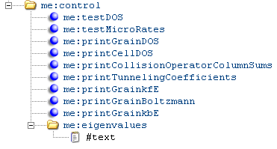
Figure 2.9: tree structure for me:control

Examples
- Basics:
To this point, it is better to provide several examples for setting up sections mentioned above. The best place to look for examples is in MesmerQA folder (see Chapter 3); however, this folder provides quality assessment of the platform user may be working on, but the examples inside the folder do not cover all the functionalities MESMER is capable of doing. A basic one atomic molecule should look like this in MESMER:
<molecule id="He">
<propertyList>
<property dictRef="me:epsilon">
<scalar>10.2</scalar>
</property>
<property dictRef="me:sigma">
<scalar>2.55</scalar>
</property>
<property dictRef="me:MW">
<scalar units="amu">4.0</scalar>
</property>
</propertyList>
</molecule>
From this view one can see that all property elements are enclosed inside propertyList element, where <atomarray></atomarray> element and <bondarray></bondarray> elements are not shown in this example. It is always a good practice to include the <atomarray></atomarray> and <bondarray></bondarray> elements in molecule as MESMER in the future may use the elemental data to check the credibility of the vibrational/rotational data provided by user.
One has to notice that any complete XML element should be one of the following
<elementName parameterName="id"></elementName>
or
<elementName parameterName="id" />
where in the first expression, child elements can be inserted between two element bodies as
<elementName parameterName="id">
<childElementName parameterName="id"></childElementName>
<childElementName parameterName="id"></childElementName>
</elementName>
, etc. Please work carefully when converting the first expression to the second expression if you are editing on a text editor, expecially on the location of the forward slash in the expression. One of the example of converting first expression to the second expression is
<me:PTpair me:units="Torr" me:P="200.15" me:T="500" me:precision="double">
<me:experimentalRate ref1="acetyl" ref2="acetyl" error="6.75E+03"></me:experimentalRate>
</me:PTpair>
If there is no experimental rates to compare with, simply remove the middle line as
<me:PTpair me:units="Torr" me:P="200.15" me:T="500" me:precision="double"></me:PTpair>
or even shorter
<me:PTpair me:units="Torr" me:P="200.15" me:T="500" me:precision="double" />
and as double is the default precision in MESMER, one can write
<me:PTpair me:units="Torr" me:P="200.15" me:T="500" />
instead.
Quad-double and double-double precisions can also be specified inside <me:PTpair> element, the syntax is
me:precision="quad-double"
me:precision="double-double"
or
me:precision="qd"
me:precision="dd"
(2) Special customs for grid search tasks:
A grid search task is enabled by both inserting an element
<me:gridSearch />
into the <me:control></me:control> elment, and giving variable range to certain number of parameters. The parameters available for grid search at the moment are zero-point energy of molecule, A∞, n∞, and E∞. The range of the parameter can simply be given, for example,
<me:preExponential lower="4.6e-12" upper="6.201e-12" stepsize="2.0e-13">6.00e-12</me:preExponential>
In this expression, there are three additional parameters for the me:preExponential element, where the order of the three parameters is not important. The first parameter gives the lowest point of the parameter; the second parameter gives the upper bound of the range; the third parameter specifies the step size of grid search for this parameter. In this case, the number 6.00e-12 within the element pair of me:preExponential is ignored in the calculation but is used to display the potential energy surface in XML parser.
To run a grid search task, first one needs to know how long does it take to run one point. If there are 11 points in A∞, 13 points in n∞, 9 points in zero-point energy to be evaluated, the task will have 1287 points to calculate in total in the phase space. If one point in precision double-double takes one minute to finish, this task will take approximately 21 hours and 30 minutes. Usually, in order to compare with the experimental results, a grid search task is done on several temperatures and pressures; therefore, it is ideal to divide a task into multiple tasks either in the category of temperatures or the category of pressures.
Each MESMER calculation creates three files, the first one is test file, the second one is log file, and the third one is a regeneration of new XML file from the old XML file, which contains some additional data from the calculation. The output files will be explained in detail in Chapter 5. To do all tasks within a folder, one can specify MESMER to output the test log into a distinctive name instead of being mesmer.test. The command
mesmer.out –N acetyl_O2_association0003.xml
will output files as the following
acetyl_O2_association0003.test
acetyl_O2_association0003.log
acetyl_O2_association0003.20080819_091523.xml
The third file is always output to associate with the original file name with additional time stamp behind it. This file contains basic information about the partition functions of the final point MESMER was working on.
(3) Additional option in me:deltaEDown
In Mesmer <ΔE_{d}> can be set to depend on temperature. The function is defined as
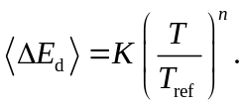
By default, n equals to 0, which means there is no temperature dependency for <ΔE_{d}>, with <ΔE_{d}> = K. User can change these values by the following syntax
<property dictRef="me:deltaEDown">
<scalar units="cm-1" lower="140.0" upper="200.1" stepsize="10.0" referenceTemperature="298" exponent="1.0">150.0</scalar>
</property>
This gives linear dependency of <ΔE_{d}> in temperature relative to the room temperature.

Test Suite

Text here to introduce the test jobs

N-Pentyl Isomerization
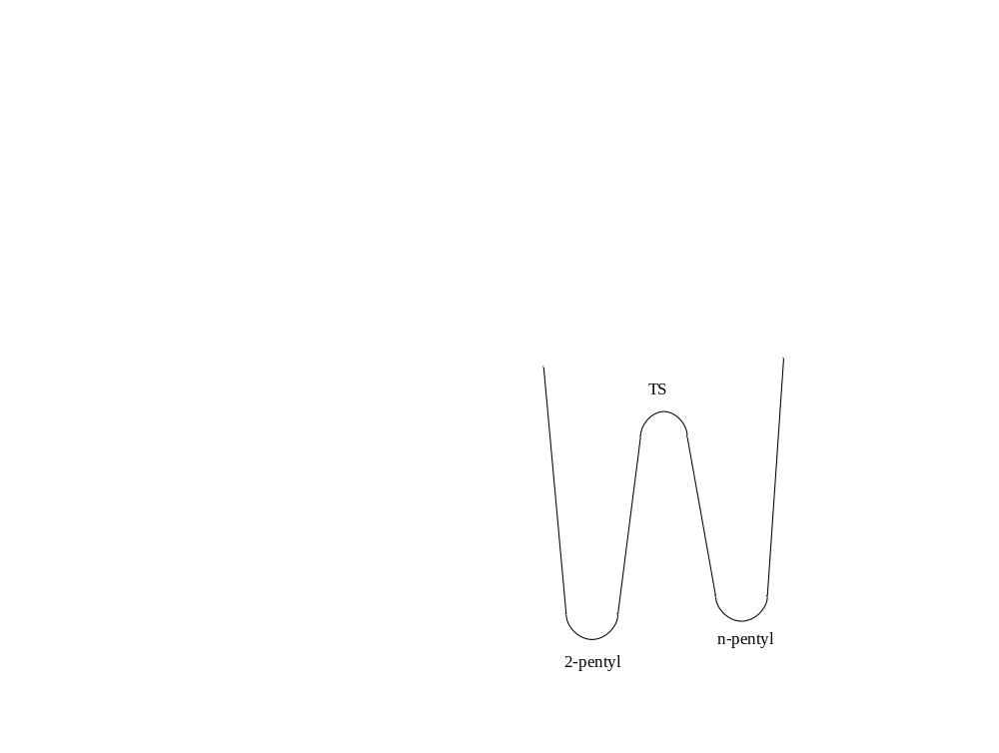
Figure 3.11: PES schematic for N-Pentyl Isomerization

Cyclopropene Isomerization
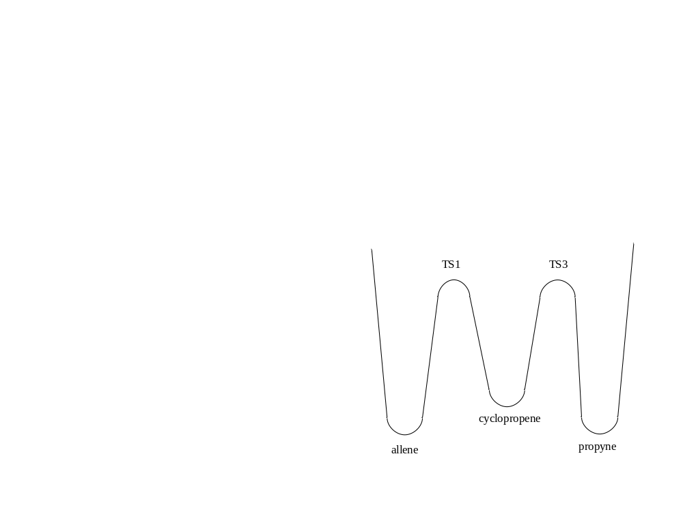
Figure 3.12: schematic of the PES used the cyclopropene isomerization test

H + SO₂
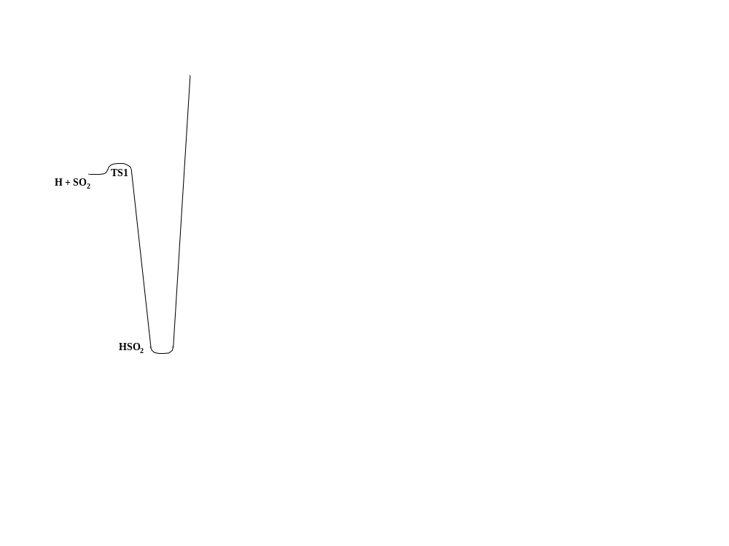
Figure 3.13: PES schematic for H + SO₂ test system

OH + C₂H₂
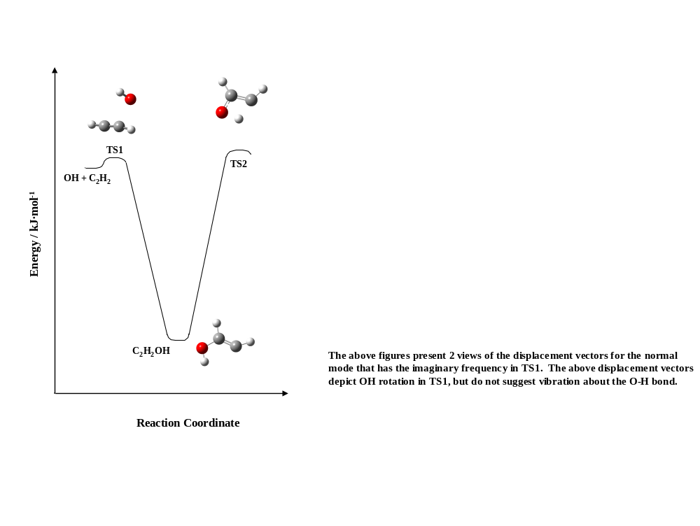
Figure 3.14: PES for OH + C₂H₂ test job

O₂ + CH₃CO

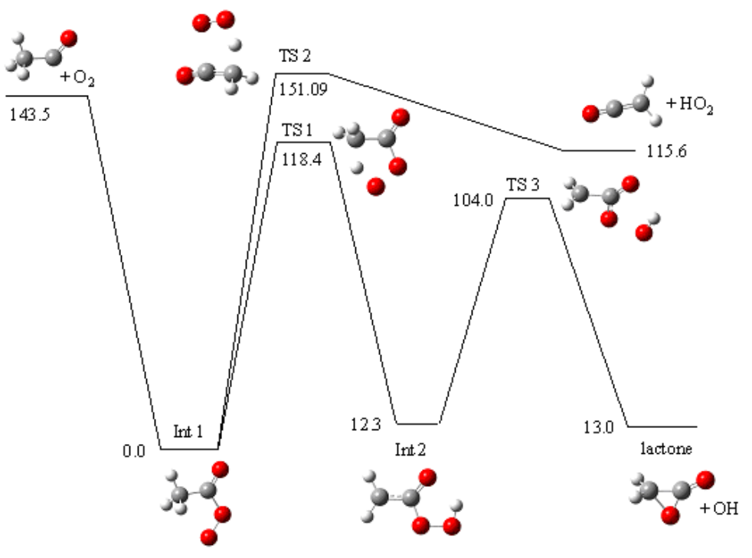
Figure 3.15: PES for O₂ + CH₃CO

Adding Functionality

Modifying the Input File

Plug-in Classes

Density of States Calculations

Microcanonical Rates Calculations

Tunneling Corrections

Collisional Energy Transfer Models

MESMER files explained
There are files in the source folder and also files produced during the calculation. This section is provided to explain the purposes of the files.

Output files of calculation
Each MESMER calculation creates three output files. They are test, log and xml respectively as decribed in Section 2.2.7. In this chapter, we are going to give detailed explaination of these files.

mesmer.test
This file contains information that user choose to print out (see Section 2.2.6). Here are titles of the items and explaination:
Test rovibronic density of states for: <molecule name>
This line is followed by columns like the following
T qtot sumc sumg
200 4.38418e+006 4.4283e+006 4.40474e+006
300 5.15155e+007 5.21956e+007 5.2071e+007
400 5.69583e+008 5.78432e+008 5.77654e+008
500 6.05474e+009 6.15825e+009 6.15289e+009
600 6.12019e+010 6.17397e+010 6.16902e+010
700 5.80337e+011 5.45991e+011 5.45139e+011
800 5.11822e+012 3.88757e+012 3.875e+012
900 4.18316e+013 2.1315e+013 2.12008e+013
which tells the canonical partition function of the species for the molecule. Column qtot is the classical approximation of the partition function by assuming molecular bonds are harmonic oscillators. This section provides a good check for the credibility of the partition function calculated by the current method. Classical approximation has better credibility on high temperatures, whereas the quantum mechanical methods that treat the vibrations by direct counting the energy ladders have better credibility on low temperatures; therefore one should expect if the cell number used by the current calculation is small, the canonical partition function predicted in high temperature will move away from the classical approximation.
Grain rovibronic density of states of <molecule name>
This section prints rovibronic density of states for the molecule in grains, where the first column is the mean state energies.
k_f(e) grains for <reaction name>
This section gives the forward microcanonical rates of the reaction in grained level.
k_b(e) grains for <reaction name>
This section gives the reverse microcanonical rates of the reaction in grained level.
Tunneling coefficients for: <reaction name>
V0 = 11201.4, V1 = 10047.3, barrier0 = 9864, barrier1 = 8834, imFreq = 5.0605e+13
This section gives tunnelling coefficients of the reaction. V0, V1 are forward and reverse classical barrier hight of the reaction, and barrier0, barrier1 are zero-point energy differences between transition state and reactant, product, respectively. The units are wavenumbers.
Eq fraction matrix:
{
-4.9732e+013 1 0
0 -0.0036887 1
1 1 1
}
inverse of Eq fraction matrix:
{
-2.0108e-014 -2.0034e-014 2.0034e-014
2.0034e-014 -0.99632 0.99632
7.3899e-017 0.99632 0.0036751
}
Equilibrium Fraction for Int1 = 0.996325
Equilibrium Fraction for Int2 = 0.00367513
Equilibrium Fraction for acetyl = 2.00339e-014
This section uses rovibronic partition functions of isomers and pseudo-isomers to calculate equilibrium constants. Consider a three well system: e.g., A ⬄ B ⬄ C where A ⬄ B has 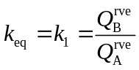 and B ⬄ C has 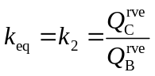. Therefore, the relation is defined by the following three linear equations:
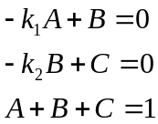
which is a 3 by 3 matrix and a vector which satisfy the following:
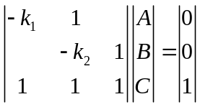
The equilibrium fraction of each isomer (or pseudo isomer, in the case of a source term) may be obtained by inverting the matrix shown above, and taking the elements in the final column of the inverse. Any system, with an arbitrary number of wells and connections, may be described by such a Matrix.
Total number of eigenvalues = 347
Eigenvalues
This section gives the eigenvalues of the reaction (system collision) operator.
Print time dependent species and product profiles
{
Timestep/s acetyl Int1 Int2 lactone
1e-011 0.999999 1.3743e-006 1.59562e-010 2.89049e-011
1.25893e-011 0.999998 1.72938e-006 2.51184e-010 3.21681e-011
1.58489e-011 0.999998 2.17595e-006 3.95081e-010 3.7701e-011
1.99526e-011 0.999997 2.73745e-006 6.20583e-010 4.90837e-011
2.51189e-011 0.999997 3.44324e-006 9.73003e-010 7.0918e-011
3.16228e-011 0.999996 4.33003e-006 1.52194e-009 1.13004e-010
3.98107e-011 0.999995 5.44372e-006 2.37345e-009 1.94525e-010
5.01187e-011 0.999993 6.84152e-006 3.68781e-009 3.51826e-010
6.30957e-011 0.999991 8.59463e-006 5.70456e-009 6.51742e-010
This section gives time dependent species and product profiles of the system. The first column is the time step in seconds, and all the following columns are the populations at the specific time step of that species.

mesmer.log
This file contains warning and error messages during the calculation. Also, it provides additional usage log of some variables when MESMER finishes calculation. It will be useful for one who is building a system manually, to check this file for any miss arguments.

XML output

Other files

source.dot and source.ps
This two files are file dependency tree structure of MESMER source code. File source.dot is produced by a PERL script cinclude2dot.pl (http://flourish.org/cinclude2dot/). The file dependency tree is a guide for programmers to avoid repeated inclusion.

mesmer1.xsl, mesmerDiag.xsl and switchcontent.xsl
These three files under the root folder provides a browser interface to XML files, where the suffix of the files stands for extensible stylesheet language. Figure 5.16 is an example of MESMER input file view cropped from Firefox 3.0.1. As the MESMER XML stylesheet uses relative pathname, in order to get the view of the XML file in browsers, one has to place XML input files two levels down in the root folder of MESMER. Otherwise, one can change the content of href in second line of the XML file
<?xml-stylesheet type='text/xsl' href='../../mesmer1.xsl'?>
so that it points to the file.
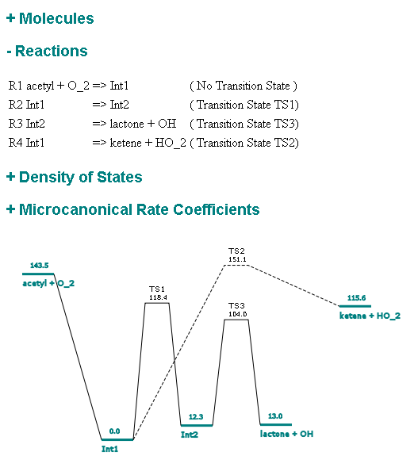
Figure 5.16

Theoretical Basis

The EGME has been described previously.²⁻⁶ The form of the EGME in MESMER is the one dimensional ME, wherein the total rovibrational energy of the system, E, is the independent variable. Indeed, other forms of the EGME consider the time dependent evolution of the system with respect to the total E as well as angular momentum, J. However, such 2 dimensional ME treatments are restricted in their application, given the difficulty of describing the transition probabilities wherein both E and J are coupled.⁴ They may only be used to solve the ME in the collisionless limit, or for a system that has a single isomer.^{7,8} Thus, the bulk of ME modelling for systems under conditions of relevance to atmospheric and combustion chemistry is restricted to a one dimensional ME.⁴
In the mathematical formulation of the one dimensional EGME, the population of rovibrational energy levels in different isomers (denoted by subscript i) on the potential energy surface are lumped into energy grains, denoted by E, and the population in each grain, n_{i}, is described by a set of coupled differential equations that account for collisional energy transfer within each isomer as well as isomerization and dissociation:
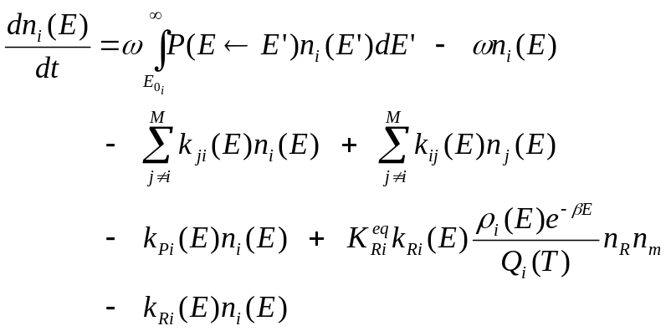
Equation 6.1
The first term in Eq 1.9 represents the probability that n_{i}(E) is populated by collisional energy transfer via activating bath gas collisions. ω is the Leonard-Jones collision frequency,⁵ and P(E←E’) is the probability that collision with bath gas will result in a transition from a grain with energy E’ to a grain with energy E. The second term represents the loss of n_{i}(E) via collisional energy transfer. The third term represents the loss of n_{i}(E) via reactions that give other isomers, denoted by susbscript j. The fourth term represents the population of n_{i}(E) by reactions from isomer j that give isomer i. k_{ji}(E) is the microcanonical rate constant for loss from isomer i to isomer j. The fifth term represents the rate of loss from n_{i}(E) via dissociation, with k_{Pi}(E), representing the corresponding rate of loss. Because reassociation of the products of unimolecular dissociation is generally negligible on an experimental time scale, dissociation to products is often treated via an infinite sink approximation – i.e., reassociation is not considered. The final two terms are associated with the so-called bimolecular source term. They only apply to those wells that are populated via bimolecular association. Assuming that the reactants are thermalized via bath gas collisions in a Boltzmannn distribution, and that a pseudo-first order approximation is appropriate, then the sixth term and seventh term represent the rate at which two reactants associate to populate n_{i}(E), and the rate of loss from n_{i}(E) via redissociation to reactants, respectively. k_{Ri}(E) represents the rate constant at which n_{i}(E) redissociates to give reactants, R, and 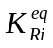 is the equilibrium constant between isomer i and the reactants. Q_{i}(T) = ∑ ρ_{i}(E)e^{-βE}, which is the rovibrational partition function for the molecular species corresponding to isomer i.
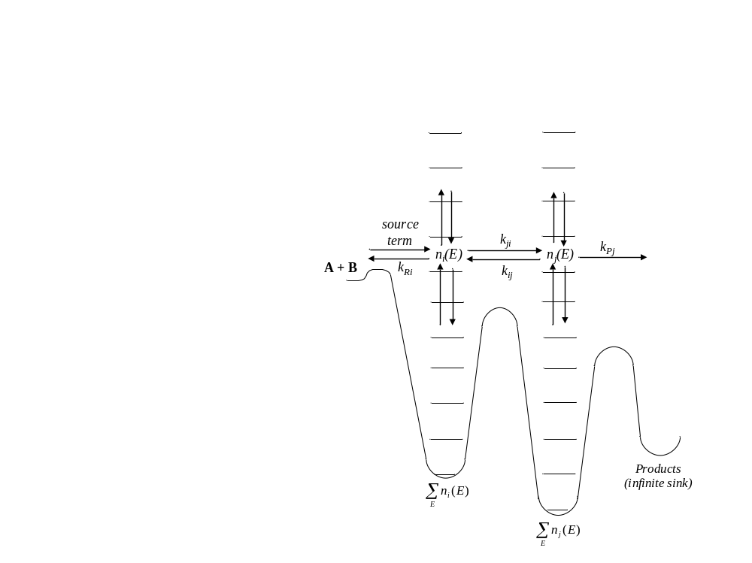
Figure 6.17: pictoral representation of Eq 1.9 for a two well system, composed of isomers i and j. The reactants, A + B, are connected to isomer i, and the product channel is connected to isomer j. This figure shows the terms of Eq 1.9 as they apply to one grain within each isomer, n_{i}(E) and n_{j}(E).
Microcanonical rate coefficients for the unimolecular reactions that occur in each energy grain, k(E), are calculated from the PES data pertaining to the reagents and transition states via the microcanonical RRKM theory expression:
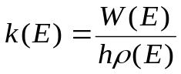
Equation 6.2
where 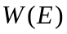 is the sum of rovibrational states at the optimized transition state geometry and ρ(E) is the density of rovibrational states of the isomer. As discussed by Baer and Hase,⁹ RRKM theory depends on the assumption that the total phase space of a molecule is populated statistically. That is, the population density of molecules in phase space may be assumed uniform as the molecule moves from the reactant phase space, through the transition state dividing surface, and into the product phase space. This is equivalent to assuming that all regions of phase space are available to the molecule – i.e, that the time scale for energy randomization within a molecule is very fast with respect to the rate of reaction, maintaining a microcanonical ensemble. This common simplification, which is fundamental to ME analysis, is called the ergodicity assumption.
Eq 1.10 is applicable for transition state dividing surfaces located at constrained geometry with a well defined energetic barrier. When the reaction in question is barrierless, a first principles determination of k(E) requires a variational approach – i.e, the k(E)s are calculated by minimizing W(E) on the PES in question. In this work, the k_{Ri}(E)s for barrierless association reactions were determined using an Inverse Laplace Transform.^{10,11} With this technique, the microcanonical dissociation k_{Ri}(E)s are determined from experimental measurements of the temperature dependent high pressure limiting rate coefficient for association. The microcanonical rate coefficients for dissociation are then determined via detailed balance, as indicated in Eq 1.9.
In general, the transition probabilities for collisional energy transfer in the EGME utilize the exponential down model:
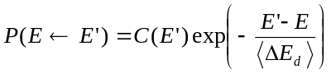
Equation 6.3
where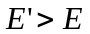, 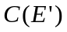 is a normalization constant, and is the average energy transferred per collision in a downward direction. The transition probabilities for energy transfer in the upward direaction may be obtained from those calculated with Eq 1.11 via detailed balance. The exponential down model is the most commonly used for describing collisional energy transfer probabilities. It derives from scattering theory, and it reflects the common sense notion that collisions which transfer lots of energy are less probable than those that transfer small amounts of energy.⁶ Other models with different transition probability distributions have been proposed,⁶ such as Gaussian models⁵ and double exponential models.⁴ In a recent review of ME techniques by Miller and Klippenstein, they noted that classical trajectory simulations as well as experimental data suggest that the exponential down model is not the most accurate for describing collisional transition probabilities.⁴ Models that produce longer tails are more accurate.
However, nearly all those ME models published in the literature utilize the single exponential down model. Other functions, such as a double exponential model, feature more parameters and systematic techniques for assigning parameter values have not been established. Additionally, given the extensive use of the single exponential down model in the literature, a set of typical values has emerged. For example, at room temperature He bath gas tends to have values from ~120-175 cm⁻¹, while O₂ and N₂ bath gases tend to have values of ~175-275 cm⁻¹. In general, is left as a variable parameter determined by fitting to experimental data, within the limits given above, and it usually shows a slight positive temperature dependence in one dimensional ME analyses. The origin of the temperature dependence is not entirely clear, although Miller suggested that this temperature dependence may correspond to rotational excitation.⁸ Classical Trajectory calculations have identified the dependence of on the angular momentum of the target molecule. Experimentally, higher temperatures correspond to higher angular momentum states, and in the 1d ME, this is manifest as an effective increase in .⁸
The collisional energy transfer models discussed above assume that the transition probability depends only on the energy of the molecule, and not on its collisional history or its configuration. The same is true of the RRKM k(E)s. Such processes, where the probability that a system occupies a particular state, depends only on the immediately previous state and nothing else, are common to many fields, and are referred to as Markov processes. Indeed, the ME in Eq 1.9 is a stochastic differential equation of the Markov type, and its relationship with the more general field of stochastic probability theory has been discussed in detail by Pilling and Robertson.⁶ So long as the time that a pair of molecules spends in collision is much smaller than the time between collisions, the molecular configuration in a collision event should not depend on the molecular configuration in the previous collision event. The energy transferred in a collision may be treated as depending only on the internal energy of the molecule, and not its configurational history – i.e., collisional energy transfer may be treated as a ‘random walk’, and the ME is applicable.^{4,6}
The coupled stochastic differential equations represented by Eq 1.9 may be reformulated as:
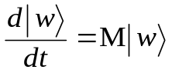
Equation 6.4
where 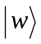 is a vector containing the populations of the grains for each isomer, n_{i}(E), and M is the matrix that describes collisional energy transfer, as well as reactive loss and gain for each grain. In the case where Eq 1.9 includes a pseudo-first order bimolecular source term to describe the fractional rates of population of the entrance well by the reactants, then the final element of corresponds to the time dependent population of the reactant that is not in excess. Eq 1.12 shows that the solution of the ME has been reduced to a standard eigenvalue problem, and diagonalization of M yields the corresponding eigenpair solutions.
Approximating the time dependent grain populations as sums of exponential functions, and combining the eigenpair solutions with the appropriate initial conditions vector for describing the system at time zero, the time dependent grain evolution for a particular isomer, n_{iE}(t), may be obtained. The solution to the ME may be written as:
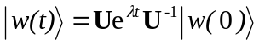
Equation 6.5
where 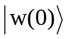 contains the initial conditions (i.e., at t = 0) for each grain (i.e., n_{iE}(0)), U is matrix of eigenvectors obtained from diagonalization of M, and λ are the corresponding eigenvalues. For a conserved system (i.e., one for which the previously discussed ‘infinite sink’ approximation has not been introduced) with S different chemical configurations (or wells), there will be S eigenpairs that are substantially smaller in absolute magnitude (i.e,. they are less negative) than the other eigenvalues. The first eigenvalue, often referred to as 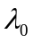, will be equal to zero, and the corresponding eigenvector gives the equilibrium boltzman distributions of the different isomers on the PES.^{6,12} For systems that utilize the infinite sink approximation, diagonalization of M does not yield , and there are S – 1 eigenvalues that are separated from the others. These S – 1 eigenvalues are often referred to as the ‘chemically significant’ eigenvalues. Along with their corresponding eigenvectors, they describe the time evolution of the system as it approaches equilibrium. The ‘chemically significant’ eigenvalues are those that determine the experimentally observed phenomenological rates measured in kinetics experiments, since they describe reaction and interconversion between the different molecular configurations on the PES.^{12,13} The remaining eigenvalues – those that are much more negative than the chemically significant eigenvalues – correspond to collisional relaxation on very short time scales, and have been referred to as the internal energy relaxation eigenvalues (IERE).^{4,14}
The formulation of the EGME in terms of grains essentially corresponds to expanding the solutions of Eq 1.12 in a basis of delta functions whose maxima lie at the centre of the grain. In general, chemical problems are not concerned with the time evolution of every single grain for a particular isomer. However, in order to obtain a convergent solution to Eq 1.12, the grain size must be smaller than , which is generally less than ~150 cm⁻¹ for the systems investigated in this work. Thus, the EGME usually contains far more information than is practically necessary. In addition, as will be discussed in subsequent chapters of this thesis, the EGME procedure described above becomes unreliable at very low temperatures and low pressures. This occurs because the collisional energy transfer transition probabilities for activating collisions exceed machine precision, and the eigenvalue algorithms become numerically unstable.¹³ Expanding the ME into a different basis may alleviate such numerical problems. The possibilities for expanding the solutions to Eq 1.12 in other basis sets has been examined by Venkatesh et al.,^{15,16} but such techniques have not been thoroughly examined nor have they received widespread implementation.
In general, EGME results are concerned with experimental observables: product yields, branching ratios, and rate coefficients, all of which may be a function of temperature and / or pressure. Extracting information about product yields and branching ratios is straightforward. The solutions to the EGME yield multiexponential functions that describe the time dependent population in each grain, and the grain populations are normalized to unity.¹² Within the infinite sink approximation, the normalized time dependent product formation is determined as follows:
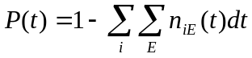
Equation 6.6
where the summations are over all isomers (including the bimolecular source term), and all energies. If only one product channel is available, then Eq 1.14 provides information regarding the time dependent product yield; however, in many cases, it is useful to calculate branching ratios. If a particular EGME model has n products, then the normalized yield of a specific product at time t, P_{ni}(t), may be written as follows:¹⁷
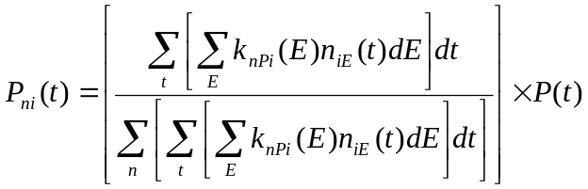
Equation 6.7
where n_{iE}(t) is the time dependent population of the energy grains spanning the entire state space of the relevant well, obtained from solution of Eq 1.12 and 1.13.
Extraction of phenomenological rate coefficients from the EGME solution for comparison with experimentally determined rate coefficients is less straightforward. In general, two methods have been proposed: one by Klippenstein and Miller,⁷ and one by Bartis and Widom.^{14,18} In the Klippenstein and Miller approach, the rate coefficient for a particular transformation on the PES is essentially obtained by taking the time derivative of the exponential expression that describes the n_{iE}(t) terms for a particular isomer. In the Klippenstein and Miller approach, extracting a particular rate coefficient for a PES requires a specific configuration for the initial conditions, such that calculating each rate coefficient requires a different initial conditions vector. The Bartis and Widom approach considers the time evolution given a particular initial condition, but permits all the rate coefficients relevant to the PES to be calculated without respecifying the initial conditions. As discussed by Robertson et al.,¹⁴ both of these approaches show an apparent dependence on initial conditions. Furthermore, while substantial numerical evidence indicates that the macroscopic rate coefficients obey detailed balance for both approaches, it has not been possible to mathematically prove this to be the case. In order to make the extraction of rate coefficients from the EGME more general, investigations of both of these issues – the initial conditions dependence and a proof of detailed balance – are desirable, and are being actively investigated.

References
¹ Miller, W. H. Tunneling corrections to unimolecular rate constants, with application to formaldehyde, Journal of the American Chemical Society, 101, 6810-6814, 1979.
² Klippenstein, S. J., and Miller, J. A. From the Time-Dependent, Multiple-Well Master Equation to Phenomenological Rate Coefficients, Journal of Physical Chemistry A, 106, 9267-9277, 2002.
³ Blitz, M. A., Hughes, K. J., and Pilling, M. J. Determination of the high-pressure limiting rate coefficient and the enthalpy of reaction for OH+SO2, J. Phys. Chem. A, 107, 1971-1978, 2003.
⁴ Miller, J. A., and Klippenstein, S. J. Master Equation Methods in Gas Phase Chemical Kinetics, J Phys Chem A, 110, 10528-10544, 2006.
⁵ Gilbert, R. G., and Smith, S. C. Theory of Unimolecular and Recombination Reactions, Blackwell Scientific Publications, Oxford, 1990.
⁶ Pilling, M. J., and Robertson, S. H. Master equation models for chemical reactions of importance in combustion, Annual Review of Physical Chemistry, 54, 245-275, 2003.
⁷ Miller, J. A., Klippenstein, S. J., and Raffy, C. Solution of Some One- and Two-Dimensional Master Equation Models for Thermal Dissociation: The Dissociation of Methane in the Low-Pressure Limit, J Phys Chem A, 106, 4904-4913, 2002.
⁸ Miller, J. A. Concluding Remarks, Faraday Disc., 119, 461-475, 2001.
⁹ Baer, T., and Hase, W. L. Unimolecular reaction dynamics: theory and experiments, Oxford University Press, New York, 324-368 pp., 1996.
¹⁰ Robertson, S. H., Pilling, M. J., Baulch, D. L., and Green, N. J. B. Fitting of Pressure-Dependent Kinetic Rate Data by Master Equation Inverse Laplace Transform Analysis, J Phys Chem, 99, 13452-13460, 1995.
¹¹ Davies, J. W., Green, N. J. B., and Pilling, M. J. The testing of models for unimolecular decomposition via inverse Laplace transformation of experimental recombination rate data, Chem. Phys. Lett., 126, 373-379, 1986.
¹² Klippenstein, S. J., and Miller, J. A. From the Time-Dependent, Multiple-Well Master Equation to Phenomenological Rate Coefficients, J Phys Chem A, 106, 9267-9277, 2002.
¹³ Green, N. J. B., and Bhatti, Z. A. Steady-state master equation methods, PCCP, 9, 4275-4290, 2007.
¹⁴ Robertson, S. H., Pilling, M. J., Jitariu, L. C., and Hillier, I. H. Master equation methods for multiple well systems: application to the 1-,2-pentyl system, Phys Chem Chem Phys 9, 4085-4097, 2007.
¹⁵ Venkatesh, P. K., Dean, A. M., Cohen, M. H., and Carr, R. W. Master equation analysis of intermolecular energy transfer in multiple-well, multiple-channel unimolecular reactions. II. Numerical methods and application to the mechanism of the C₂H₅+O₂ reaction, J. Chem. Phys, 111, 8313-8329, 1999.
¹⁶ Venkatesh, P. K., Dean, A. M., Cohen, M. H., and Carr, R. W. Master equation analysis of intermolecular energy transfer in multiple-well, multiple-channel unimolecular reactions. I. Basic theory, J. Chem. Phys, 107, 8904-8916, 1997.
¹⁷ Miller, J. A., and Klippenstein, S. J. From the Multiple-Well Master Equation to Phenomenological Rate Coefficients: Reactions on a C₃H₄ Potential Energy Surface, J Phys Chem A, 107, 2680-2692, 2003.
¹⁸ Bartis, J. T., and Widom, B. Stochastic models of the interconversion of three or more chemical species, J. Chem. Phys, 60, 3474-3482, 1974.

Appendices
Inverse Laplace Transform
Dissociation ILT
...
Association ILT
...
The final result of discociation ILT is thus,
...
The constant C’ follows from the translational partition function,
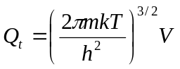
where all quantities are in standard SI units. For ease of computation, it is useful to re-write 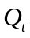 in terms of the molar mass M (g/mol) and the reciprocal temperature 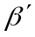expressed in wave numbers:
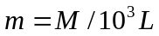
= hc/kT
where L is Avogadro’s number and c is the speed of light expressed in cm/s, otherwise all quatities are in SI units. Inserting Eqs. () and () into () gives:
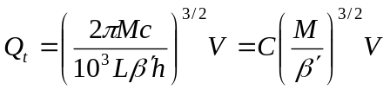
where is given by
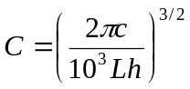
Volume is more conveniently expressed in cm³ and to account for this Eq. () can be written as
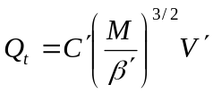
where 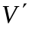is the volume now expressed in cm³ and the constant 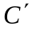is given by,
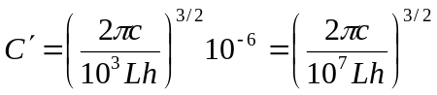
Substituting in 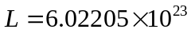, 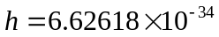Js and 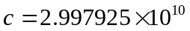cm/s gives 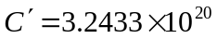 (mol/g/cm)^{3/2}. This is the value that is defined in the constant.h file of the MESMER source code.

Mesmer FAQ
Mesmer definitions and frequently asked questions:

Mesmer parameters:
What is qtot?
What is sumc?
What is sumg?
What is conc?

Mesmer reactions:
What is a unimolecular reaction? And how does its potential energy surface look like?
What parameters account for energy difference between a reactant(s) and product(s) of an association/dissociation reaction in Mesmer?

How many types of reactions does Mesmer concern? How are they defined?

AssociationReaction
IrreversibleReaction
IsomerizationReaction
ExchangeReaction

Mesmer units:
How do we input values into Mesmer? What unit systems are there available? Are the units converted automatically?

Mesmer conventions:
What is the file naming convention of Mesmer? What filename Mesmer takes and gives during calculation?

